Linux Namespace
- Network Namespace is a separate network inside the host.
  - Host and Namespace doesn’t know anything about each other.
- The namespace will have its own network interfaces, arp table, routing table (independent of Host).
- I’ve 2 vms: vm1, vm2
vm1: 10.10.10.10/24
vm2: 10.10.10.11/24
- vm1 and vm2 can ping each other
because both belong to same LAN (10.10.10.x).
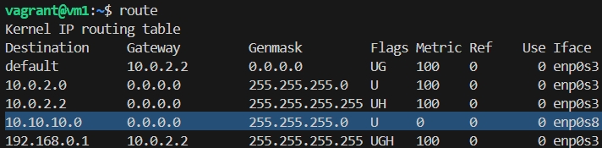[vm1 route table]
Gateway 0.0.0.0 means this subnet (10.10.10.0) Gateway/Router is not needed because both belong to same subnet.
10.10.10.0 is added on enp0s8 (means this interface is connected to private network i.e. vm to vm communication)
- ip add
display all the network interfaces names like l0 (loopback), enp0s3, enp0s8 ..etc.
en: ethernet; p0: PCI bus 0; s3: slot 3
enp0s8: ethernet device on slot 8
in out VM (vm1, vm2), lo enp0s3 enp0s8 will be there.
s3 is for vm-to-vm communication (inter LAN), s8 is for internet access (NAT).
- To create a namespace
ip netns add <namespace name>
  - We’ll create 2 namespaces having name red, blue .
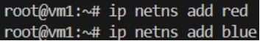
  - ip netns list
to list all the namespaces
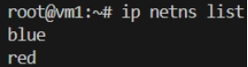
- To execute any command inside a namespace
ip netns exec <network namespace name> <command to execute>
  - ip netns exec red ip add
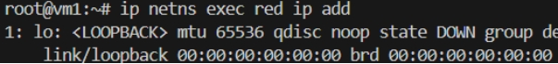
[ only loopback is present ]
[ same for blue namespace as well ]
  - ip netns exec red route
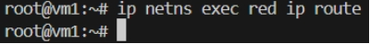
[ no route is present ]
[ same for blue namespace as well ]
- Now we’ll create a veth pair (just like a virtual cable) to connect the 2 namespaces.
ip link add <veth’s one end name> type veth peer name <veth’s another end name>
[ when you create a veth pair, it creates 2 veth network interface in the host and connect them internally. From outside, it looks 2 ends of a virtual ethernet cable ]
  - ip link add veth-red type veth peer name veth-blue
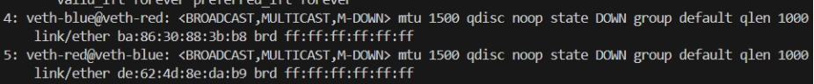 [ ip add ]
[ 2 veth network interface; internally connected; both represents one one end ]
veth-blue@veth-red -> veth-blue interface is connected to veth-red
veth-red@veth-blue -> veth-red interface is connected to veth-blue
  - If both the ends of a veth pair present in same place (ex: both in host), then it is displayed like
end1-name@end2-name (end1 to end2)
end2-name@end1-name (end2 to end1)
if both are present in different namespaces (host & namespace; or namespace1 & namespace2), then it’ll be displayed like
end1-name@if<end2’s index at its namespace>
end2-name@if<end1’s index at its namespace>
- To connect veth ends to namespaces
ip link set <veth end name> netns <network namespace name>
- Connect veth-red end to the namespace red
ip link set veth-red netns red
  - Now if you see,
link-netns red it means other end is present in namespace red.
  - veth-red@veth-blue is gone
because veth-red is now connected to a namespace. Host linux (host) cannot show peer interface directly it moved to namespace.
  - veth-blue@veth-red got updated to veth-blue@if5 because veth-red’s index inside namespace red is 5.
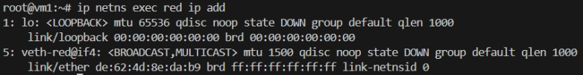
[ ip netns exec red ip add ]
And also, here, veth-red@if4 because veth-blue is at 4th index .
link-netnsid 0 means other end present in host.
- Connect veth-blue to the namespace blue
ip link set veth-blue netns blue
  - Now, veth-blue will be gone from host because it belongs to namespace blue.
- Network interfaces in both namespace now
  - Namespace red:
ip netns exec red ip add
    - 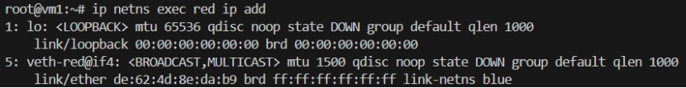
    - link-netns blue : other end is in namespace blue
  - Namespace blue:
ip netns exec blue ip add
    - 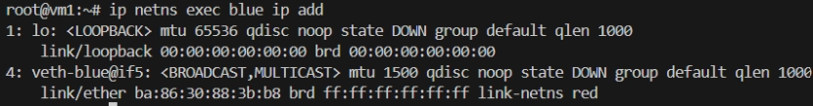
    - link-netns red : other end is in namespace red
- Now make the network interfaces in both namespaces UP.
ip netns exec <network namespace name> ip link set <interface name> up
  - ip netns exec red ip link set lo up
ip netns exec red ip link set veth-red up
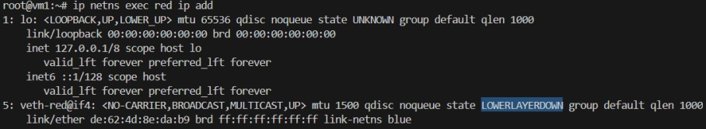
LOWERLAYERDOWN: means it is up, but its other end (veth-blue) is down.
  - ip netns exec red ip link set lo up
ip netns exec red ip link set veth-red up
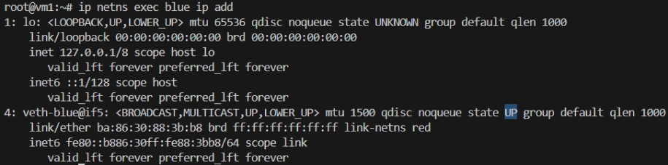
  - Now, both veth-red and veth-blue are UP.
- Assign IP to both the namespace
ip netns exec <namespace name> ip addr add <IP>/<subnet mask length> dev <interface name>
  - Assign in namespace red:
ip netns exec red ip addr add 192.168.15.2/24 dev veth-red
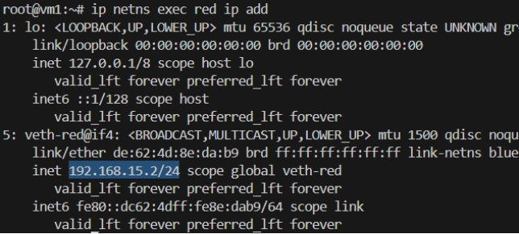
[ IP is assigned ]
  - Assign in namespace blue:
ip netns exec blue ip addr add 192.168.15.3/24 dev veth-blue
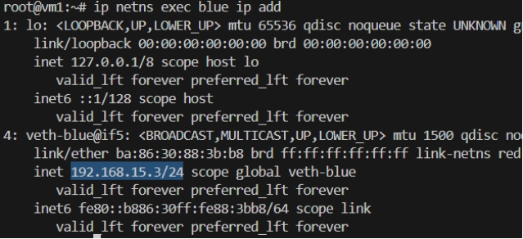
  - The IPs are 192.168.15.2/24 & 192.168.15.3/24,
so private LAN’s network IP will be: 198.168.15.0
& subnet mask will be: 255.255.255.0
- Ping the namespaces from each other. It’ll work fine.
  - From namespace red:
ip netns exec red ping -c 4 192.168.15.3
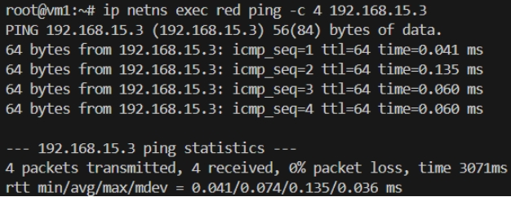
  - From namespace blue:
ip netns exec blue ping -c 4 192.168.15.2
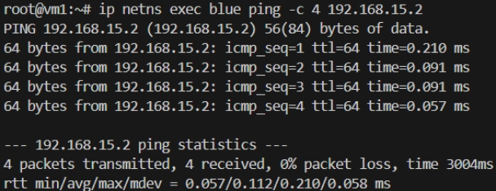
- Check arp table in both namespace, it should be updated.
  - In namespace red:
  - In namespace blue:
- But in Host’s arp table, nothing related to namespaces will be there.
Because both are separate.
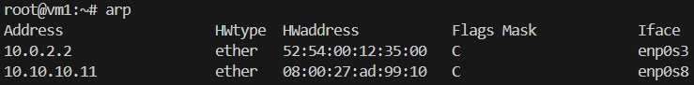
- Try to ping the namespaces from Host.
ping -c 4 <namespace network interface IP>
  - Ping to namespace red:
ping -c 4 192.168.15.2
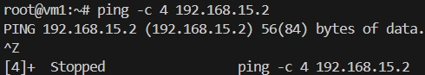
FAILED
  - Ping to namespace red
ping -c 4 192.168.15.3
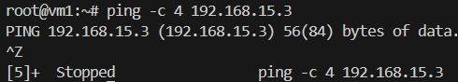
FAILED
  - It is failing because there is no connection between host and namespaces.
Create a veth pair and connect that to host and namespace, then only you can ping.
[ however, both end present in the host initially, just connect one to a namespace ]
- To test connection between host and a namespace (let red), create a veth pair and connect one end to the namespace.
Another end will be by default connected to host.
  - ip link add veth2-red type veth peer name veth2-red-host [ create veth pair ]
  - ip link set veth2-red netns red [ connect veth2-red end to namespace red ]
  - ip netns exec red ip link set veth2-red up [ make the link up in namespace ]
  - ip link set veth2-red-host up [ make the link up in host ]
  - netns exec red ip addr add 192.168.25.2/24 dev veth2-red [ assign ip in namespace ]
  - ip addr add 192.168.25.3/24 dev veth2-red-host [ assign ip in host ]
  - ping -c 4 192.168.25.2 (ping from host to namespace)
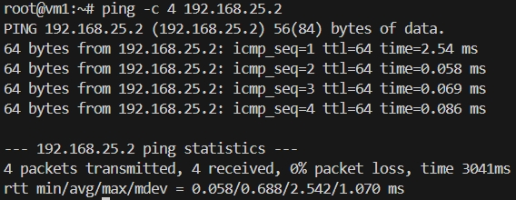
  - ip netns exec red ping -c 4 192.168.25.3 (ping from namespace to host)
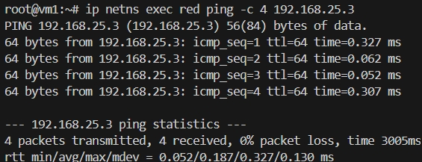
  - Here we did the same thing, before connected veth pair from namespace to namespace; not connected veth pair from host to namespace.
But, we had pinged to 192.168.25.2 (not 15.2 which is previous veth’s subnet)
  - You can add gateway in host
ip route add <network-ip> via <gateway-ip>
ip route add 192.168.15.0 via 192.168.25.2
but need to enable packet forwarding inside namespace red. Because linux doesn’t forward packets by default.
  - But, one issue will be there,
we configured 192.168.15.0 via 192.168.25.2
but the namespace blue also have this subnet, for that also it’ll send to red namespace because gateway is 192.168.25.2
  - We’ll do this in broader picture; not namespace level;
- We had 2 namespaces so one veth and directly connect both.
In case of multiple namespaces, need to create a bridge.
[ inside linux, virtual switch can be created ]
- Delete all the veth pairs.
ip link delete <any one end name>
[ it’ll delete the other name by default ]
  - ip netns exec red ip link delete veth-red
  - ip link delete veth2-red-host
- Create a bridge
ip link add <bridge interface name> type bridge
  - ip link add v-net-0 type bridge
  - [ ip add ]
its coming as a normal network interface only.
  - Linux bridge is nothing but a network interface like others.
  - The bridge belongs to the namespace where it is created.
If created in host, it belong to the host.
If created in a namespace, it belong to that namespace.
- Make the bridge network interface UP.
ip link set v-net-0 up
- Now create a veth pair, connect one end to the namespace red and another to bridge.
  - ip link add veth-red type veth peer name veth-red-br [ create veth pair ]
  - ip link set veth-red netns red [ connect one end to namespace red ]
  - Now in host [ ip add ]
  - ip link set veth-red-br master v-net-0 [ connect another end to bridge ]
[ for master node’s interface, use master <host’s interface name> ]
  - ip netns exec red ip link set veth-red up [ make namespace end up ]
  - ip link set veth-red-br up [ make bridge end up ]
- Do the same for blue namespace.
  - ip link add veth-blue type veth peer name veth-blue-br [ create veth pair ]
  - ip link set veth-blue netns blue [ connect one end to namespace red ]
  - Now in host [ ip add ]
  - ip link set veth-blue-br master v-net-0 [ connect another end to bridge ]
  - ip netns exec blue ip link set veth-blue up [ make namespace end up ]
  - ip link set veth-blue-br up [ make bridge end up ]
- Now assign IPs to both red and blue namespace
  - ip netns exec red ip addr add 192.168.15.2/24 dev veth-red [ assign IP to red namespace ]
  - ip netns exec blue ip addr add 192.168.15.3/24 dev veth-blue [ assign IP to blue namespace ]
- Now, ping from one namespace to another will be successful.
  - Ping red to blue
ip netns exec red ping -c 4 192.168.15.3
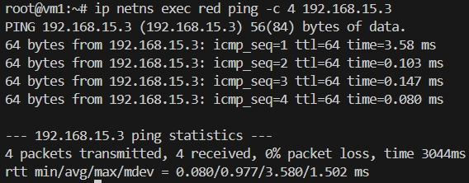
  - Ping from blue to red
ip netns exec red ping -c 4 192.168.15.3
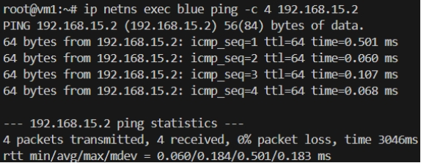
- But, Host cannot ping either of these namespace
  - Host to namespace red
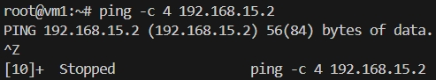
  - Host to namespace blue
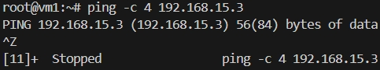
- Add IP address to the bridge network interface (v-net-0)
ip addr add 192.168.15.5/24 dev v-net-0
  - Because till now host doesn’t know any subnet of 102.168.15.x
- Now try to ping again.
  - Not it’ll be successful
because, host has now a interface having the same subnet as that of the namespaces.
  - Host to namespace red
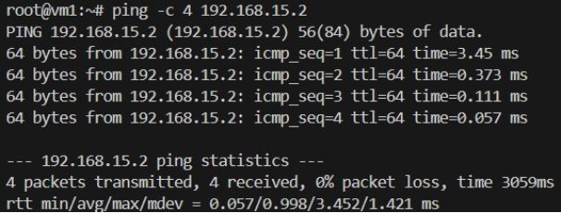
  - Host to namespace blue
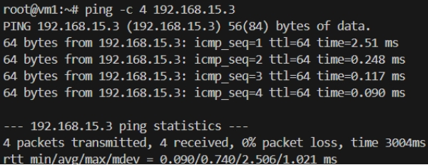
- Ping from namespace to host should also work.
But to 102.168.15.5 (bridge network interface IP) only.
It’ll not work for 10.10.10.10 (host (vm1) IP)
  - Namespace red to host
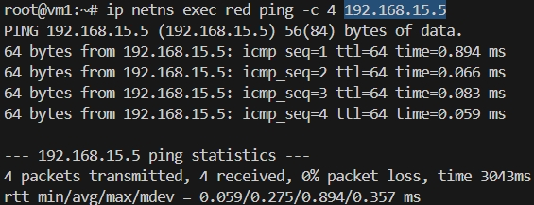
  - Namespace blue to host.
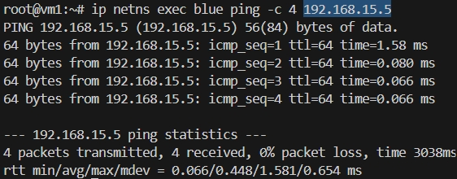
  - To 10.10.10.10 will not work
[ ‘Network is unreachable’ comes when gateway is not there ]
- Add gateway in the namespaces
network subnet: 10.10.10.0
gateway: 192.168.15.5 [ bridge network interface’s IP]
  - ip netns exec red ip route add 10.10.10.0/24 via 192.168.15.5 [ in namespace red ]
  - ip netns exec blue ip route add 10.10.10.0/24 via 192.168.15.5 [ in namespace red ]
[ always add the subnet /24, otherwise it’ll take 32 by default ]
- Now try to ping host (10.10.10.10) from namespaces
  - Namespace red to host
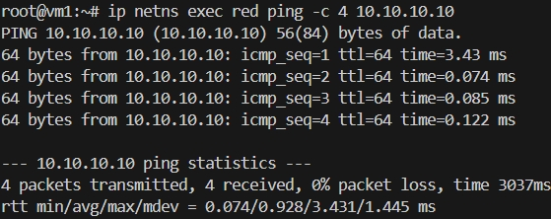
  - Namespace blue to host
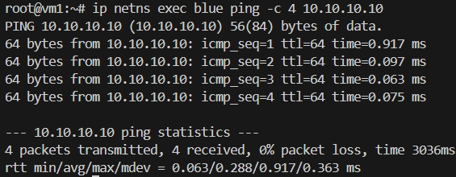
- Now try to ping vm2 (10.10.10.11) from the namespaces.
It’ll ping (because gateway is there) but response will not come.
  - Namespace red to vm2
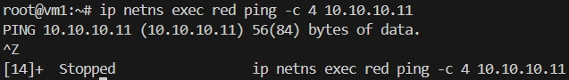
  - Namespace blue to vm2
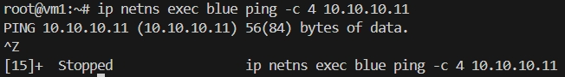
  - It is because, packet is going to vm2 (10.10.10.11), but it doesn’t know about 192.168.15.x because it belongs to private network of vm1 (host).
  - Either add a gw in vm2 or enable NAT in vm1.
- Option-1: adding gateway in vm2
network: 192.168.15.0
gateway: 10.10.10.10 (vm1 / host)
  - ip route add 192.168.15.0/24 via 10.10.10.10 [ vm2 ]
  - 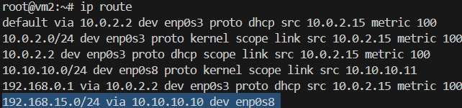 [ vm2 ]
[ ip route ]
  - Even now ping from namespace to vm2 or vice-versa will not work.
Because, IP forwarding is disable in vm1 (host)
cat /proc/sys/net/ipv4/ip_forward
0: disabled
1: enabled
  - vm1 OS is acting as the gateway and router for different networks.
10.10.10.x network
& 192.168.15.x network.
  - A router’s main job is receive packet from a network, and forward that to another network.
Here, vm1 OS is acting as a router, receiving from one network and forwarding to another. So, packet forwarding needs to be enabled.
  - Enable ip forwarding
echo 1 > /proc/sys/net/ipv4/ip_forward
  - Now ping will work
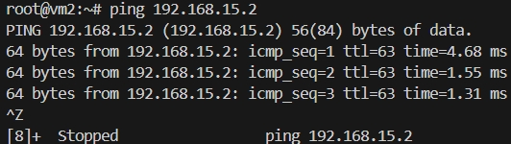 [ vm2 to namespace ]
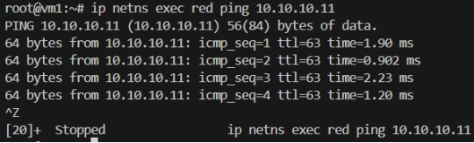 [ namespace t vm2 ]
  - In this case, vm2 can directly communicate to namespace (of vm1).
- Option-2: using NAT
  - Previous option is not preferable because if multiple systems will be there, in each system we need to set route gateway.
  - If we enable NAT in vm1, it’ll update the source IP before the packet exits.
    - Packet before NAT:
src IP: 192.168.15.2 (red namespace)
dest IP: 10.10.10.11 (vm2)
    - Packet after NAT:
src IP: 10.10.10.10 (host/vm1 IP)
dest IP: 10.10.10.11 (vm2) --> it doesn’t change.
  - Now the packet can go to vm2 easily, and vm2 as well send back the response.
src IP: 10.10.10.11
dest IP: 10.10.10.10 (because this was the source IP received at vm2)
  - vm1 (host) will receive the packet. And from the NAT table it knows that this packet belong to 192.168.15.2 (red namespace).
Now it updates the packet’s dest IP
src IP: 10.10.10.11 (vm2, doesn’t change)
dest IP: 192.158.15.2 (red namespace)
  - First delete the created configs (vm2 route gateway).
Don’t disable IP packet forwarding (/proc/sys/net/ipv4/ip_forward) because NAT requires this.
  - iptables -t nat -A POSTROUTING -o <network interface name> -j MASQUERADE
-t: use NAT table
POSTROUTING: modify packet before leaving
<network interface name>: network interface connected to vm2
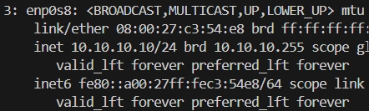 [ in my case enp0s8 ]
MASQUERADE: replace source IP with host/router IP
[ for incoming traffic, destination ip will be updated (host IP to namespace’s IP). it looks like DNAT but it is not. Kernel automatically reverse NAT mapping because it remembers previously source IP was changed ]
    - iptables -t nat -A POSTROUTING -o enp0s8 -j MASQUERADE
  - Now, from namespace to vm2 can be easily accessible.
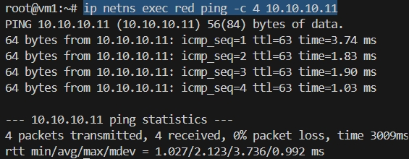 [red to vm2]
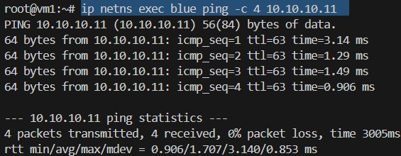 [blue to vm2]
  - But, vm2 to namespace will not be accessible.
Namespace to vm2:
when vm2 receives the packet, src ip: vm1’s ip, dest ip: vm2’s ip
so, vm2 also sends the packet, src ip: vm2’s ip, dest ip: vm1’s ip
at the end, vm1 forward the packet to namespace.
[ in this scenario, vm2 is sending packet to vm1 only, not to namespace ]
  - But, directly if you try to access namespace from vm2 it’ll not work because vm2 doesn’t know about namespace.
If you want this only, then route needs to be added in vm2 .
  - Port forwarding can be used in this case.
Vm2 will send packet to vm1 at a particular port. Vm1 will forward the packet to namespace.
It is DNAT.
  - iptables -t nat -A PREROUTING -p tcp --dport 8080 -j DNAT --to-destination 192.168.15.2:80
Packets arriving on port 8080 should be redirected to namespace 192.168.15.2:80
  - I ran a simple nodejs in namespace red on port 80,
curl http://10.10.10.10:8080 [ from vm2 ]
